INTRODUCTION

Overview

Now a days ,job hunting is the most important thing for all of us ,for that resume is the most important tool .we spend many hours for perfecting our resume ,making sure that outlines our skills and experience in the best possible way But after all that work we are still not getting enough interviews ,even for jobs you know we are qualified for .why not? We are realizing that our resume usually doesn’t go to a human being after we submit it goes computer.

Infact ,there’s a good chance a real person will never see your resume!

That’s because more and more employers are using (**Application Tracking System)**to see our resume .In this documentation we are going to learn that how they work, and especially how we can beat “them”!

purpose

**Application tracking system** is a software for Recruters and employers to track candidates throughout the recruiting &hiring process. It is a computer software designed to scan resumes for certain keywords and weed out the ones that don’t match the job description.**ATS**software includes features such as resume, parsing, candidate screening,and assessment tools.

3.RESULT

3.1.Data model:

|  |  |  |  |  |  |  |  |  |
| --- | --- | --- | --- | --- | --- | --- | --- | --- |
| |  |  | | --- | --- | | Object name | Fields in the object | | Object -1 | Field label : Recruiters  Data Type: Recruiter | | Object-2 | Field label: Apples  Data type: Apple | | Object-3 | Field label: Oranges  Data type: Orange | |

3.2 Activity and Screenshot :

Creation of recruiter object:

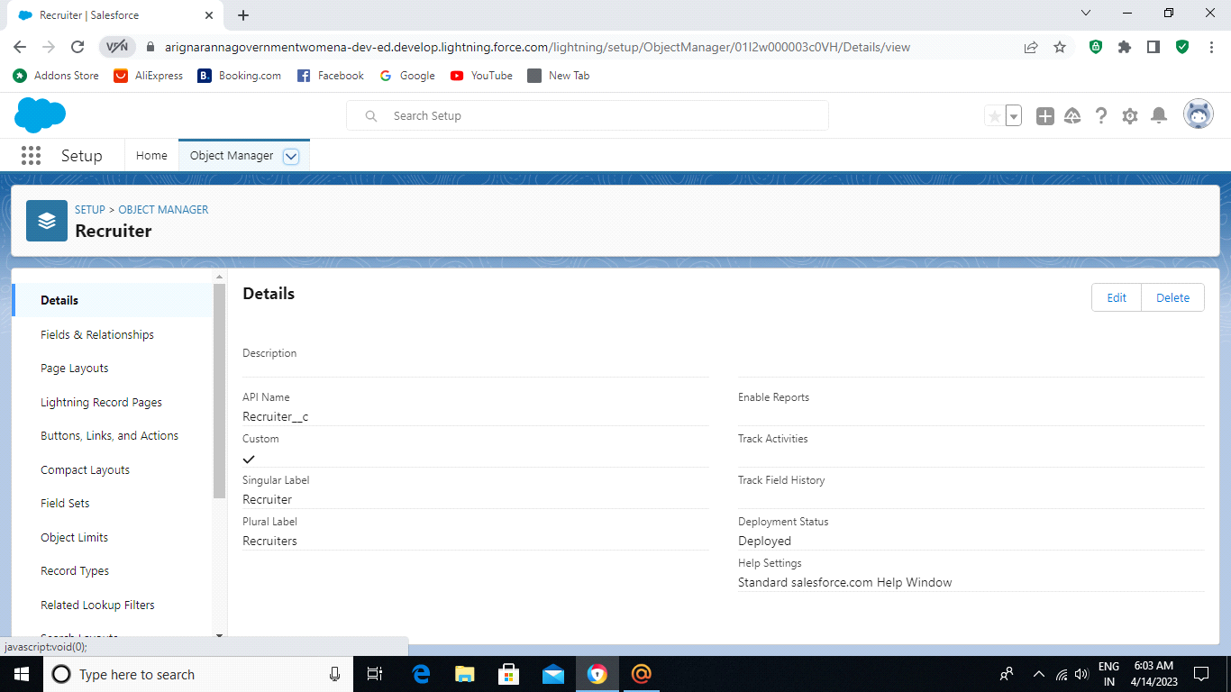

Creation of apple object:

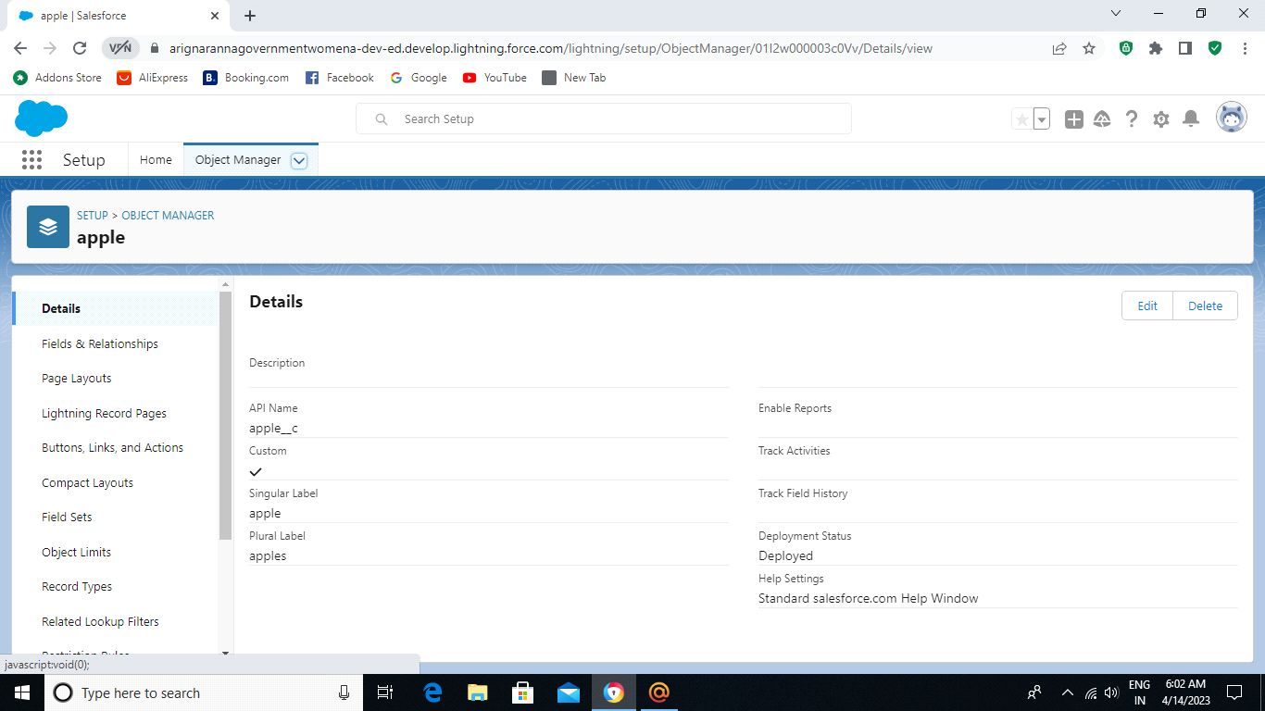

Creation of orange object:

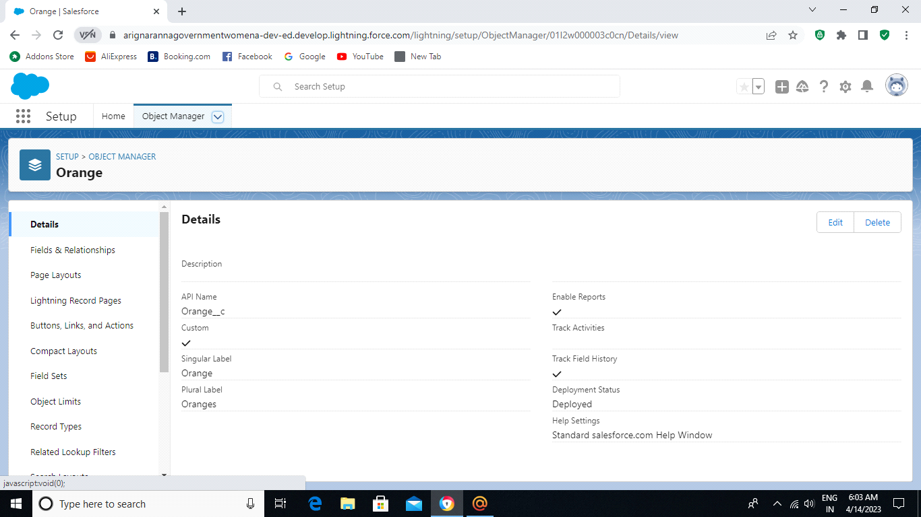

Field and Relationship:

Creation for the custom fields:

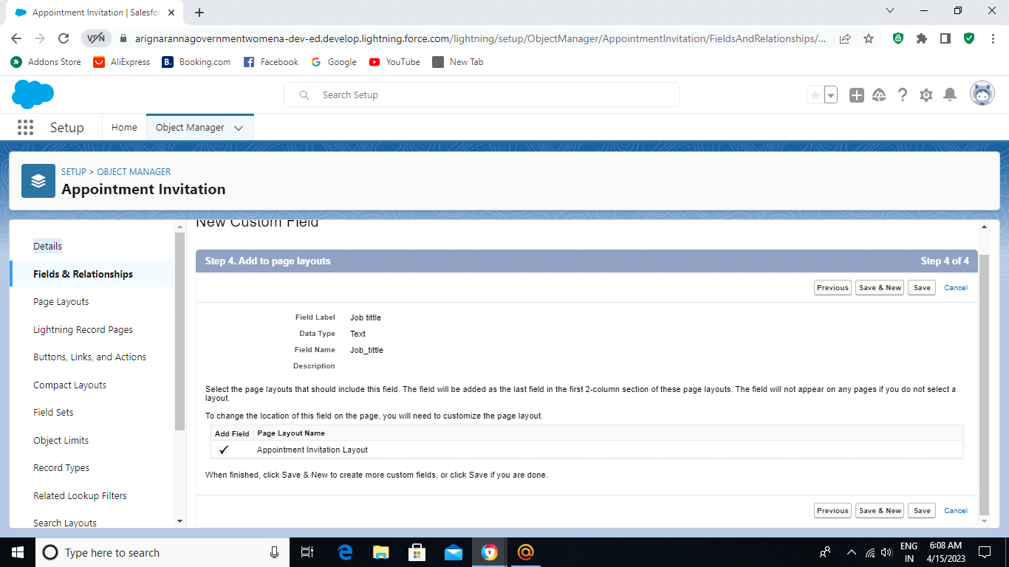

Creation of Master Detail Relationship:

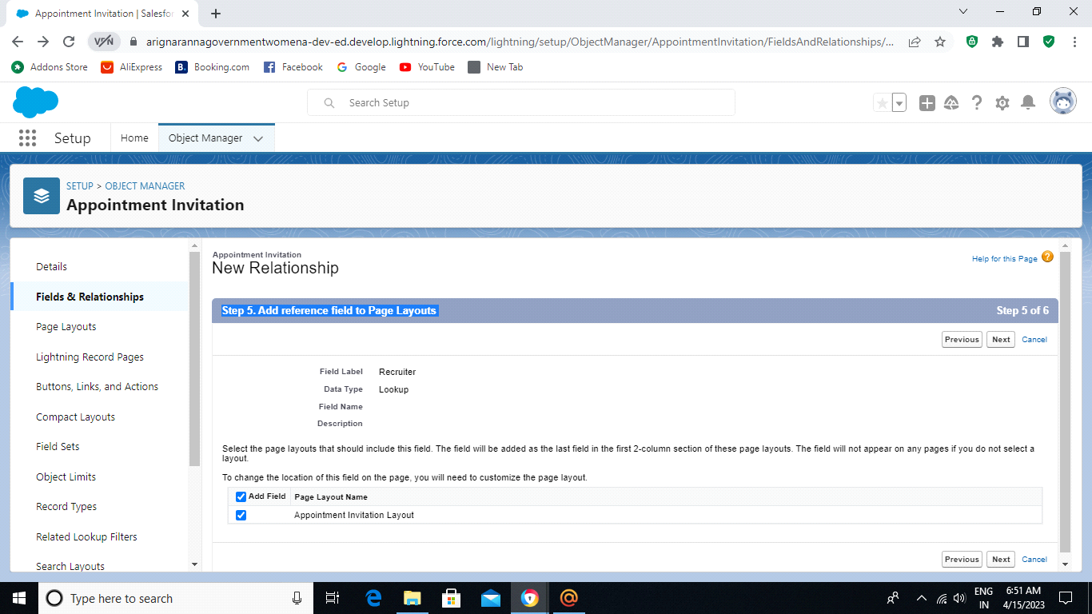

Creation of new custom field:

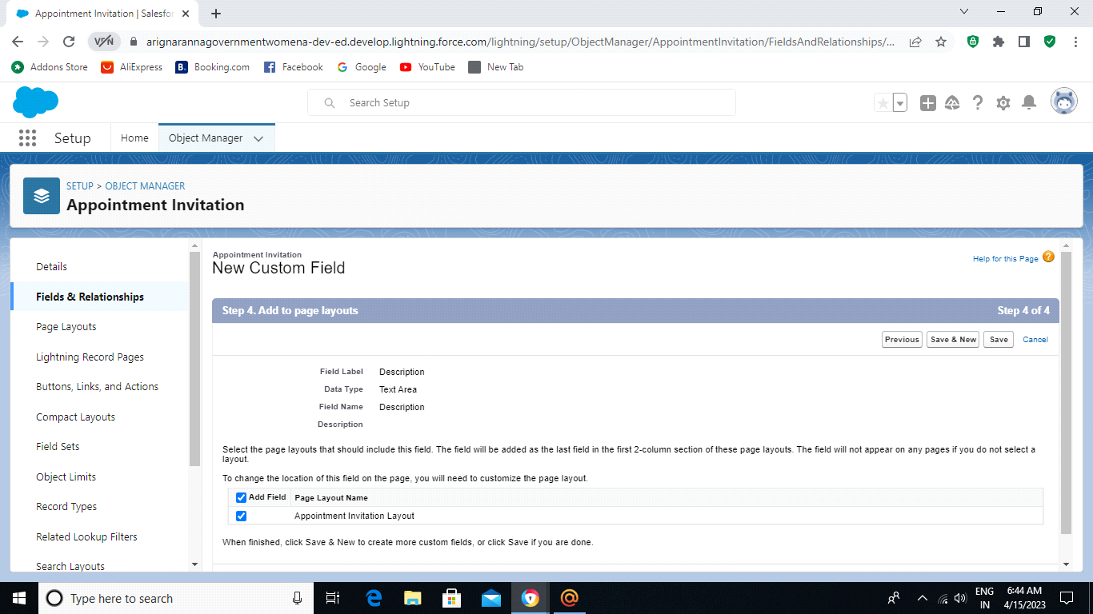

Creation of new custom field:

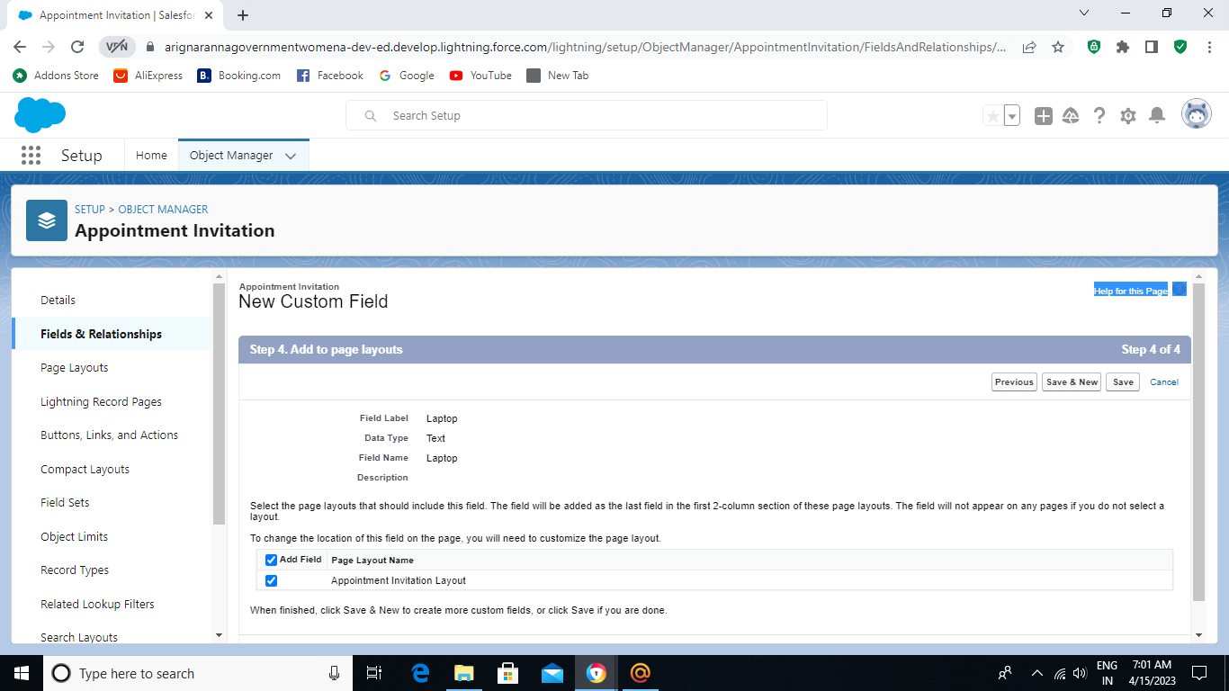

Tab:

Creation for the tab:

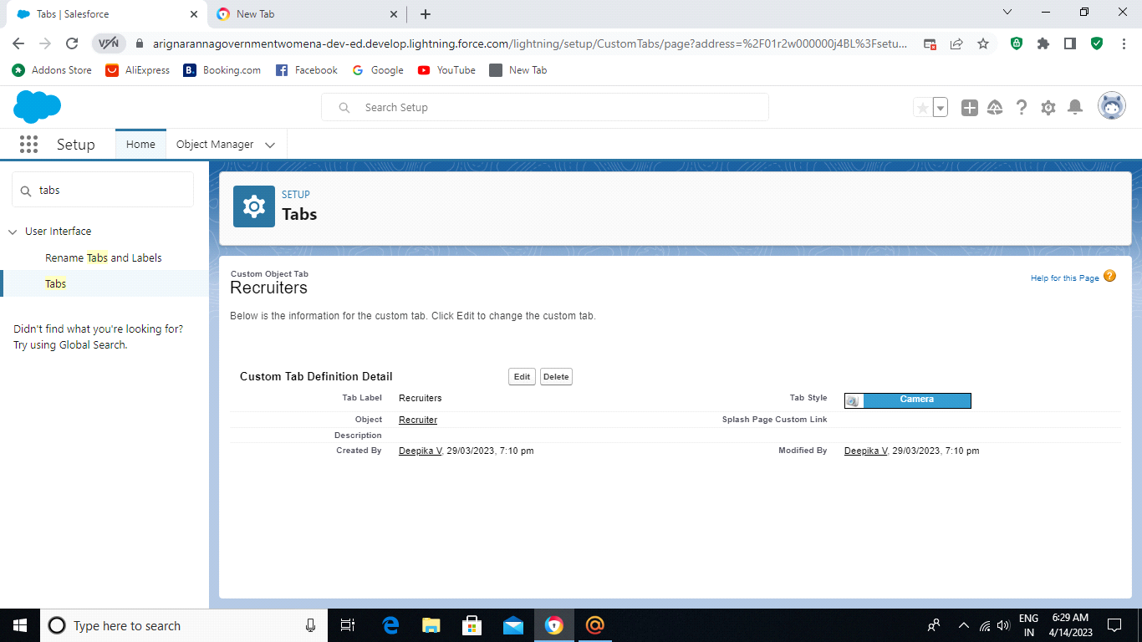

Profile:

Creation for the custom profile:

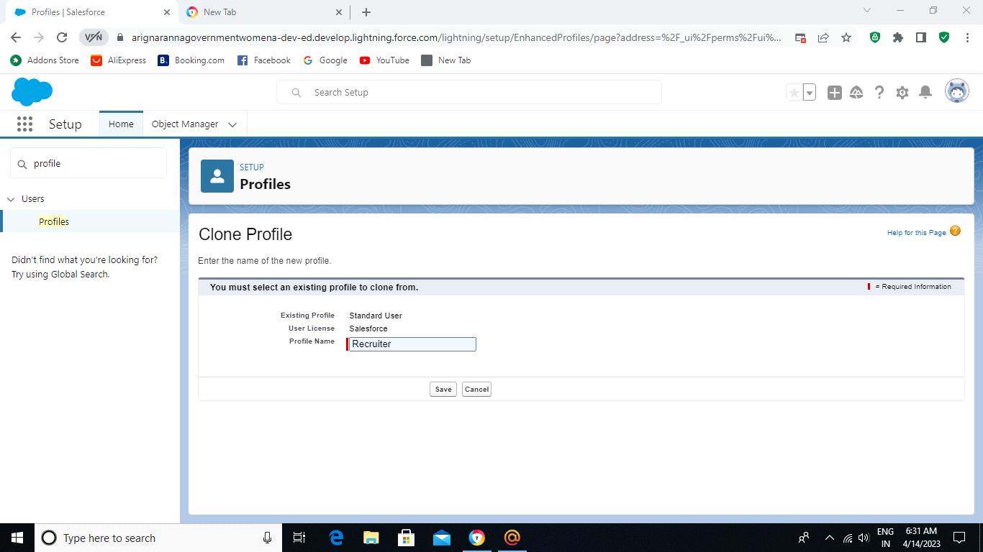

Creation profile for the sales manager:

User:

Creation for the custom user:

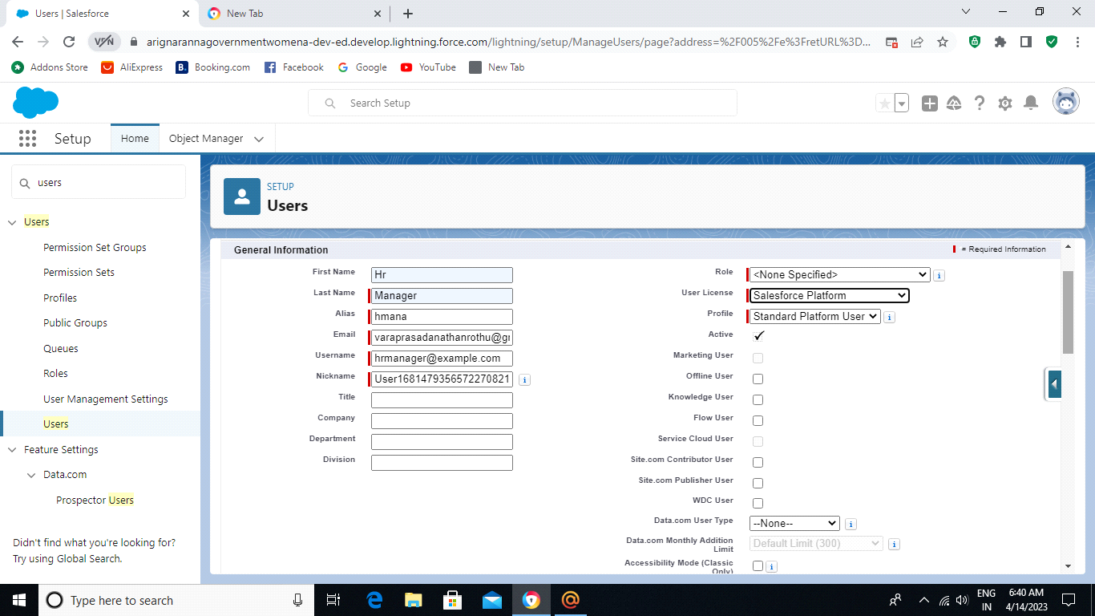

Creation user for the Ganesh Gelli:

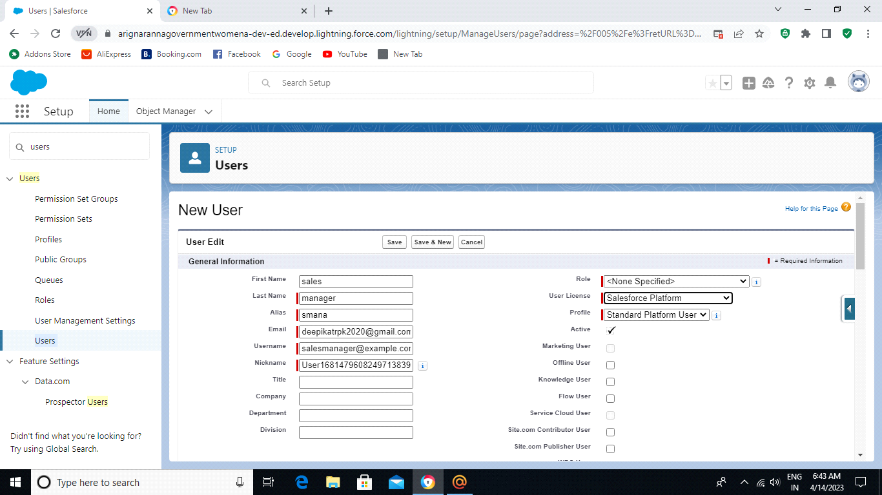

Sharing Rule:

Create a sharing rule:

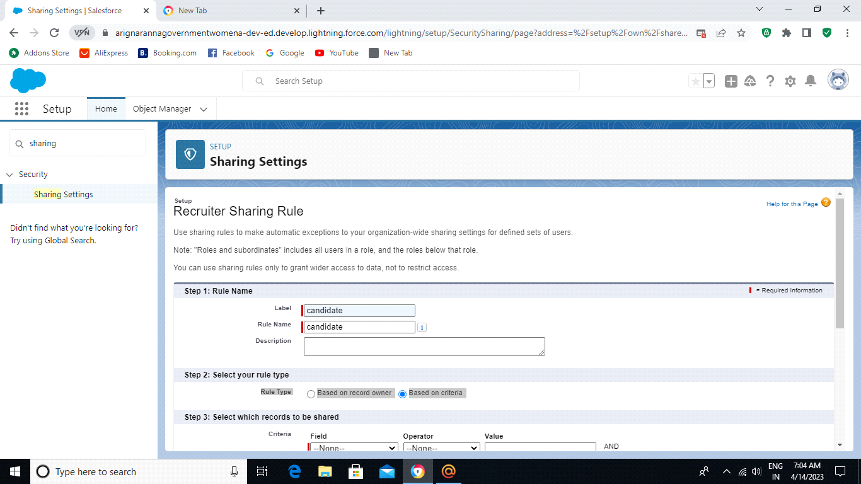

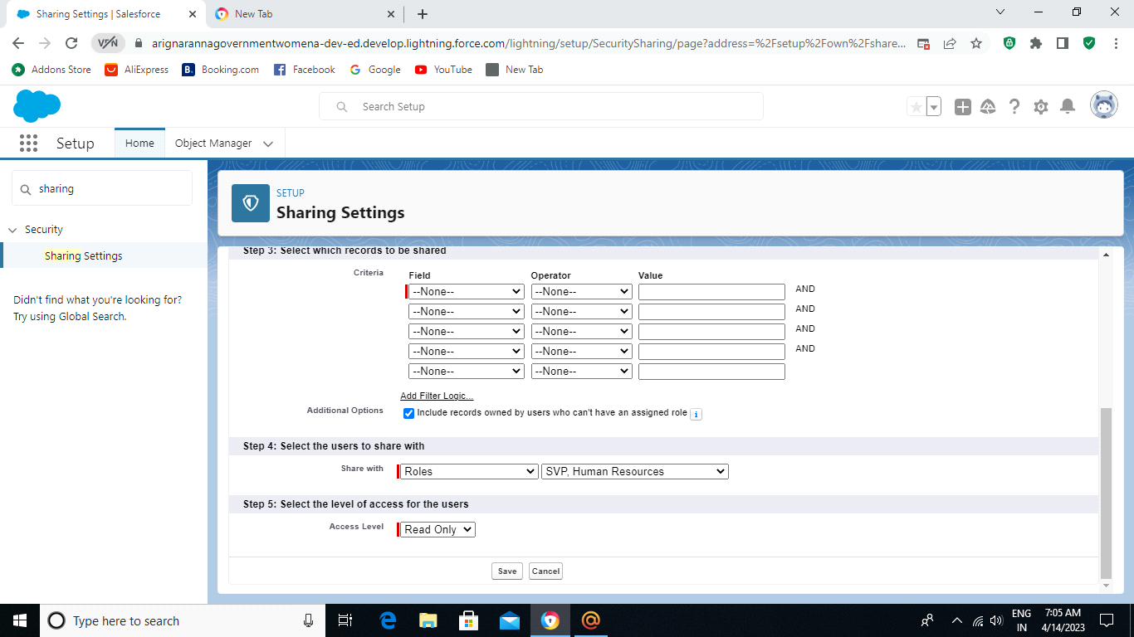

Create a sharing rule to share the records of job application to Hr Manager:

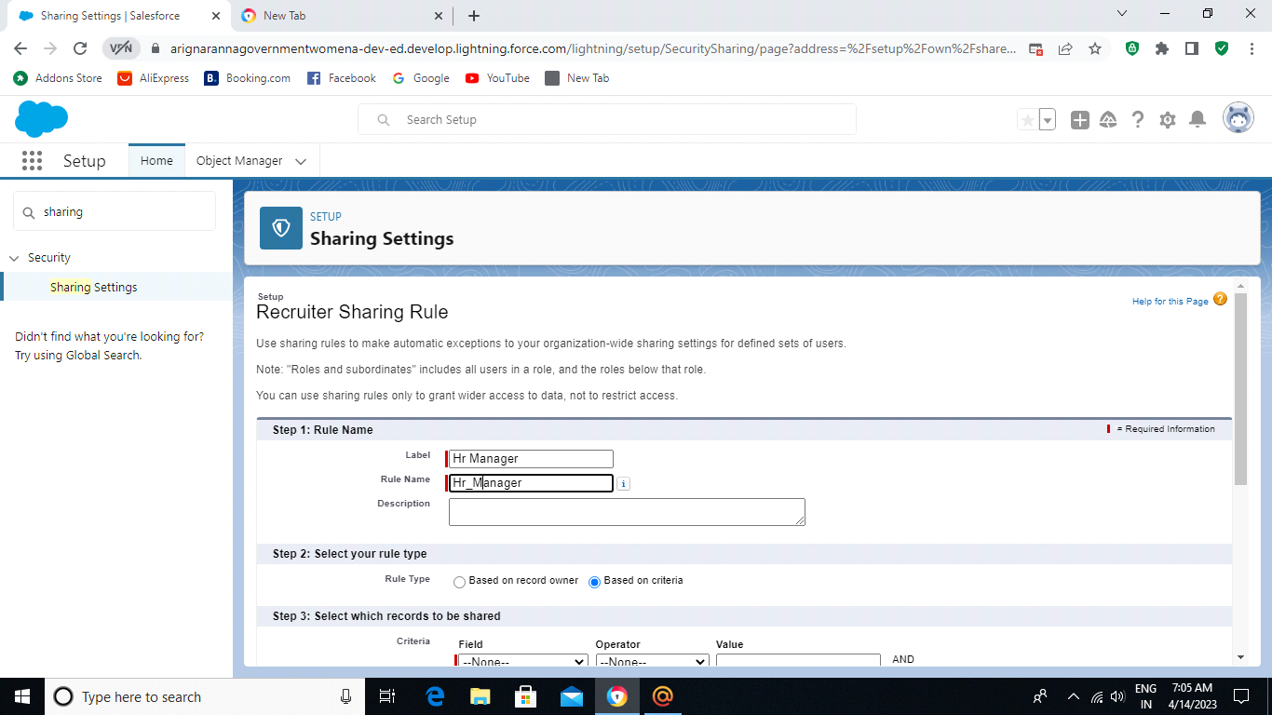



Reports:

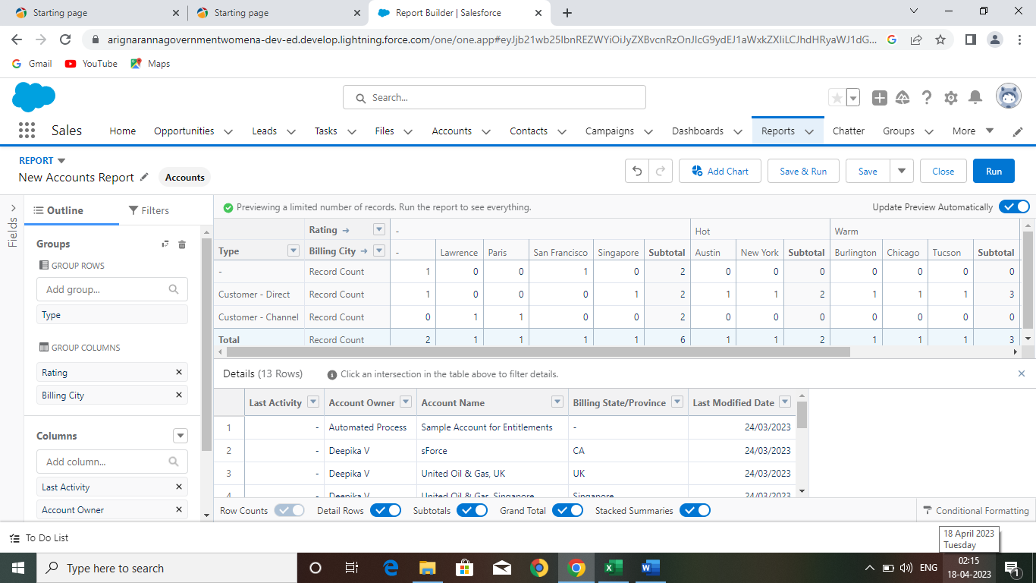

4.Trailhead profile public URL:

Team Leader: <https://trailblazer.me/id/deepika0812>

Team Member 1: <https://trailblazer.me/id/shesan693>

Team Member 2: <https://trailblazer.me/id/gdhem1>

Team Member 3: <https://trailblazer.me/id/hemak62>

Team Member 4: <https://trailblazer.me/id/bmanjunathan>

**APPLICATION :**

An Applicant Tracking System or ATS all in one human resource software that automates the hiring process, helps HR teams efficiently manage every part of recruitment and solves recruiters challenges and

pain point.

Specifically, the ATSL:

* Stores job candidate information like resumes, cover letter, references, and other recruitment and hiring data that HR teams can easily access and organize.
* Tracks job candidates and their application status throughout the hiring pipeline.
* Weeds out unqualified candidates and recommends the best fit for a position based on the parameters set moved to the next stage of the hiring process.
* Automates time-consuming administrative task such as manually screening applicants, reading resumes, scheduling interviews. And sending notification and emails to job candidates and employees.

**ADVANTAGES**

Hiring and tracking applicants is more complex than ever before with hiring managers and recruiters stretched of candidates and find the proverbial needle in a haystack. For a quick, expedited process to find the “Perfect Candidate”, recruiters and hiring managers have turned to Recruiting Software, including Applicant tracking systems (ATS) to improve almost every aspect of the recruiting process.

1. **Reduces time spent On admin tasks**

ATS software allows you to automate various tasks of the hiring process that can save you a lot of time and free up your recruiting personnel for other high-value tasks. Posting to multiple job boards, tracing candidate applications, notifying candidates individually and scheduling interview feedback can all be automated. Not only will it speed up the time it will increase the overall quality through standardization.

1. **Resume and CV screening**

With recruiter receiving 100s of resumes per role, even scanning can take a lot of time ATS software can be utilized to review application and filter out candidates that don’t meet the minimum requirements of the roles. So, the number of resumes a recruiter need to review a can be reduced drastically using per-screening questions or word searches within resumes. Once again, a recruiter’s time can be redirected to higher value items of the business.

1. **Speeds up the recruitment cycle**

Having candidates information centralized on a single platform given recruiters access to organized information allowing them to review and compare candidates more easily and quickly, which leads to a lower cost-per-hire. All communications, including notes, interviewer ratings, cases, and more can be stored and viewed in one location, which simplifies and speeds up the evaluation process.

**DISADVANTAGES**

**1** . **Could Filter Out Good Candidates**

When “Programming” your recruiting software to recognize common keywords around roles and responsibilities, you could end up filtering out good candidates that have atypical experiences that have atypical experience or lack keyword that are aligned with that you are looking for. Careful consideration of your filters and a quality assurance process will a quality assurance process will help to fine tune the filter and reduce filtering as well, So automation, in most situations, has a net benefit.

1. **Communications can be Less Personalized**

When automating responses to candidates, your messaging will be less personalized and can come off as robotic. Tacking additional time to construct good communication can help make it feel more personalized. It’s much better to send a less personalized communication than no communication at all.

**CONCLUSION**

Applicant Tracking system for recruiters is a very effective hiring solution that most of the successful recruiters utilize. Because without it, there is a good chance that your process of moving applicants through different stages can become very different. This tool is very important for optimizing the hiring process with the help of artificial intelligence and technology. As we move forward, the ATS tools are evolving and making the monotonous tasks easy.